MEDIA ALERT MEDIA CONTACT:
October 29, 2020 Amber Arnett-Bequeaith a.k.a. Queen of the Haunts
816.842.4280/913.406.7833
The Beast 1300 W. 13th St., KCMO 64102

Beauty at the Beast – The Headless Horseman Rides Again
Rescued Majestic Horse Slated for Slaughter will make Appearances at the Beast

Kansas City, Missouri – According to the Humane Society, over 100,000 horses are sent to slaughter annually in the U.S., and rehoming is rare despite the vast majority are considered in good condition. However, one fortunate Blue Roan Quarter horse has been saved from an eastern Texas kill shelter and will make special appearances with the headless horseman atop this beauty at the Beast Haunted House in Kansas City’s West Bottoms.
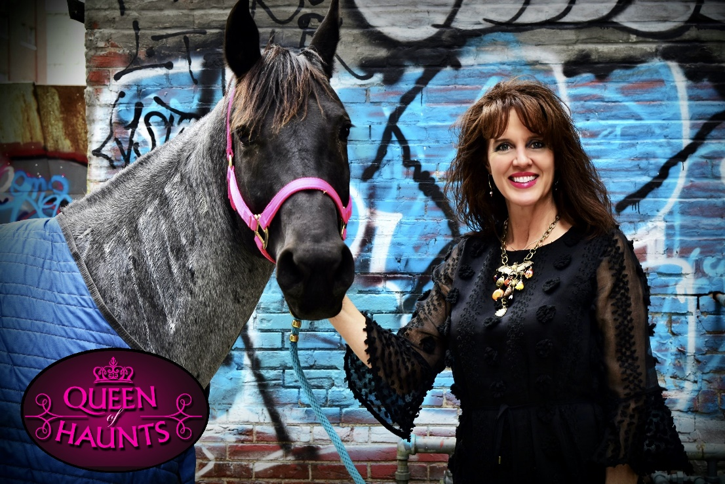
Though Kansas City’s acclaimed haunted houses, the Beast and Edge of Hell, have no mercy scaring people, they have a passion for caring for animals. Aside from the bats, they appreciate flying freely in the area; these haunt creators have the world’s record-breaking snake, Medusa – a reticulated python that turned 16 this year. Her handler, Larry Edgar, has a penchant for this apex predator, and other notable snakes, that earn their keep addressing snake phobias at the Edge of Hell. The haunt also features the pet rats of Rat Man and his real-life daughter, RatBrat, who greet guests at the haunt entrance. The rats are so tame that they love being ‘groomed’ by Rat Man and RatBrat, who put them in their mouths.

The Beast has a gator, a tarantula, and now with the new acquisition, has a horse for the Headless Horseman. Amber Arnett-Bequeaith, also known as the Queen of Haunts, competitively rode horses in her youth, and has incorporated her horses in the haunted attractions and festivals her family started. Several years ago, her beloved horse became too old to perform and was retired to a pasture to live out her days. Since then, the haunt hasn’t had a horse.

“Some horses love being in the show, and some don’t. When we find a horse that loves it as much as the haunt fans love to see them, we know we have a winner,” said Arnett-Bequeaith. “Sometimes, you just follow your heart and I had to save one I saw online. I went to the shelter where they were to be slaughtered and found this perfect mare. I would’ve saved more if possible.”

“We’ve named her Blueberry Sapphire. From the moment I touched her I could tell she longed for attention and compassion; she’d be perfect around strangers at the haunt. We gave her a test run and were pleased she loved the attention,” Arnett-Bequeaith added. The haunt has set up a GoFundMe to help pay the $50,000 for Blueberry’s care, and to acquire and care for four additional horse-mates for Blueberry that could perform at the Edge of Hell as the Biblical four horsemen of the apocalypse. The Headless Horseman will ride again but his horse needs some friends that the public could visit and help expose them to children that have never interacted with horses.

For haunt fans looking to make a donation to help animals and save on tickets, the Beast and Edge of Hell accept cans of dog and cat food in exchange for $5-off per ticket. The cans will be donated to the Great Plains SPCA Pet Adoption Center - one of the largest no-kill animal shelters.

About Beast and Edge of Hell Haunted Attractions.
The Beast and Edge of Hell are world-class haunted house attractions located in Kansas City’s Historic West Bottoms District, near downtown off the 12th Street Bridge. The haunts have always made it a priority to help children and pet charities, including the anti-bullying program “Don’t Be A Monster.” The Edge of Hell Haunted house is the oldest, continually operated haunted house in the nation with its start in 1975 and showcases the world-record breaking snake. While the Beast Haunted House is celebrating its 30th anniversary season in 2020 and is consistently recognized as one of the best haunted houses in the nation – named the best by America Haunts in 2019. The area’s attractions also include the Ghost and Gangsters Ghoul Bus Tour and the Full Moon Escape rooms. The West Bottoms haunted attractions Macabre Cinema and Chambers of Poe haunted houses did not open in 2020.

###

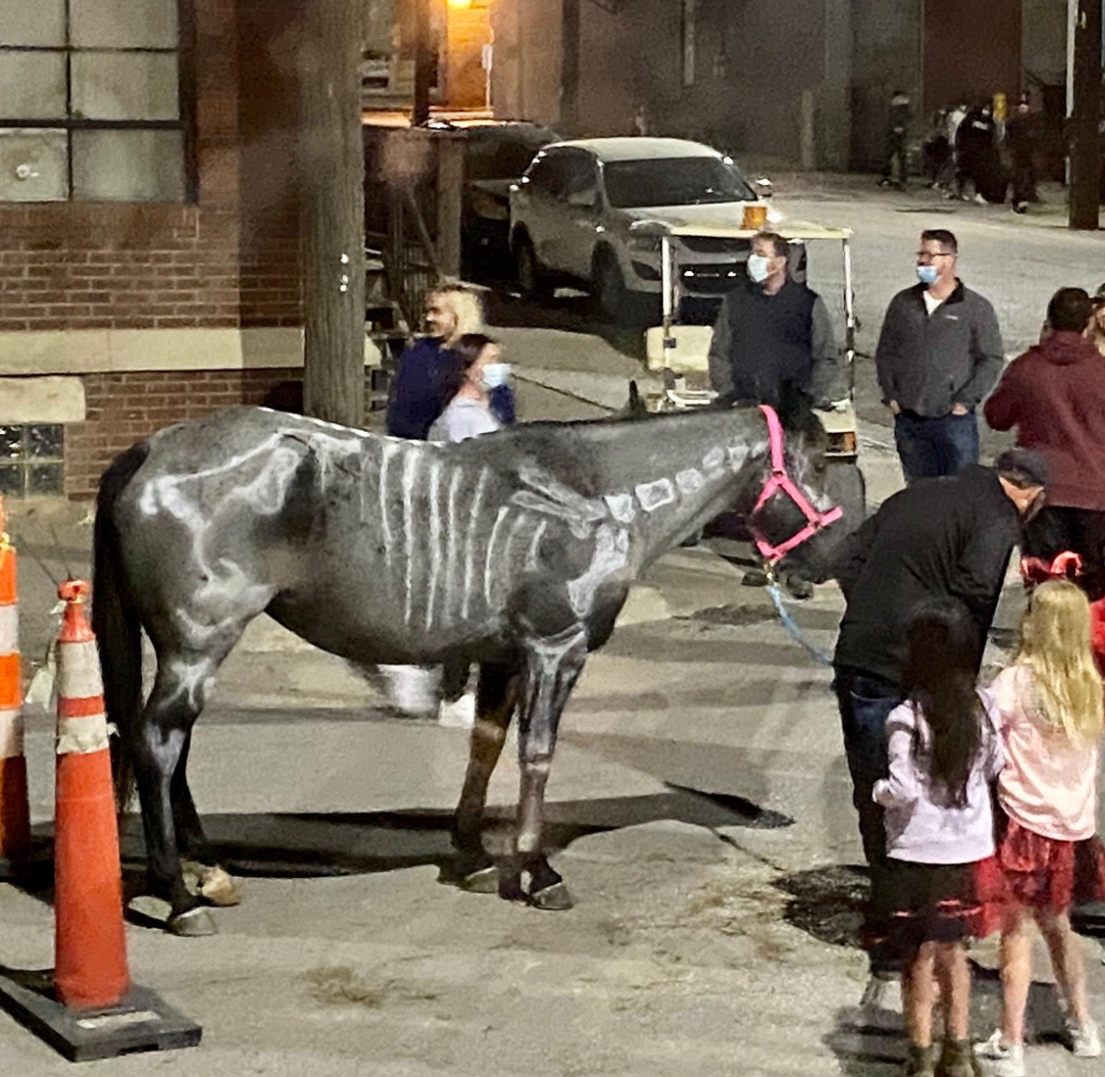
https://bit.ly/34CHINK

The Beast Haunted House celebrates its 30th anniversary season scaring visitors and consistently being named one of the best in the nation. The 2020 Beast brings the scares with customers' nose and mouth masked before witnessing Beast favorites including voodoo, a live alligator, werewolves, phantoms, and monsters. This medieval time warp goes to the era when an eye for an eye was practiced and exposes the barbaric Beast within the man. This journey is through 4 floors where the Beast is scaring up fun.
COVID 19: Customers must wear cloth masks. Costume masks that could cause confusion with employees will not be allowed. Temperature checks and metal detections before entry and hand sanitization. Temperatures over 99.6 will not be admitted. Social distancing rules will apply in lines. Staff special training and signage posted. Plexiglass is installed at the ticket booth and a UVC light will be used for sanitation on the thumb scan. Time spacing between groups will be applied.
Times: Open Friday and Saturday nights (7:30pm) from through November 7. Also opened Thursday 10/29 and Sunday 11/1. Closing time varies when the fog lifts on the Werewolf Forrest.
Place: Kansas City’s Historic West Bottoms District, off the 12th Street Bridge
Address: The Beast: 1401 W. 13th, suite B, KCMO 64102
Digital: kcbeast.com facebook.com/kcbeastedge Twitter @TheBeastKC and Instagram @Beast_and_Edge_of_Hell
Tickets: Single tickets $27 and discounts available with combo ticket purchase with Edge of Hell
Festival: Each weekend Festival of the Full Moon is a feast for the senses on the streets around the world-famous West Bottom haunted houses. Scare cast and special treats offered in socially-distanced lines.

The 46th Halloween season tradition of visiting the Edge of Hell is underway in 2020. Visitors go through the depths of hell in this multi-story haunted house. The haunt features phobias and a five-story fright from heaven to hell plus the world’s record, longest, living snake. Rat Man, vampires, and the devil on hand in your path by purgatory, hounds of hell, and stone-cold crypts.
COVID 19: Customers must wear cloth masks. Costume masks that could cause confusion with employees will not be allowed. Temperature checks and metal detections before entry and hand sanitization. Temperatures over 99.6 will not be admitted. Social distancing rules will apply. Staff special training and signage posted. Plexiglass is installed at the ticket booth and a UVC light will be used for sanitation on the thumb scan. Time spacing between groups will be applied.
Times: Open Friday and Saturday nights (7:30pm) through November 7. Also opened Thursday 10/29 and Sunday 11/1. When Hell freezes over closing times can vary per night depending on crowd size. Come early.
Place: Kansas City’s historic West Bottoms Entertainment District off the 12th Street Bridge, near Kansas City Downtown
Address: Edge of Hell: 1300 W. 12th St., KCMO 64101
Digital: edgeofhell.com | facebook.com/kcbeastedge | Twitter @TheBeastKC, Instagram @Beast_Edge_of_Hell
Tickets: Single ticket $27 and discounts available with haunt combination ticket with the Beast.

