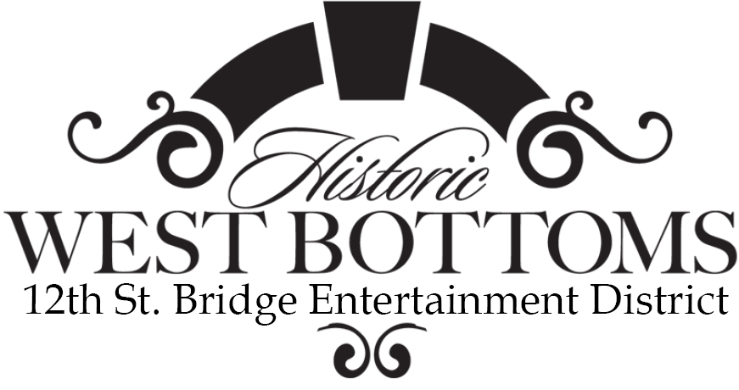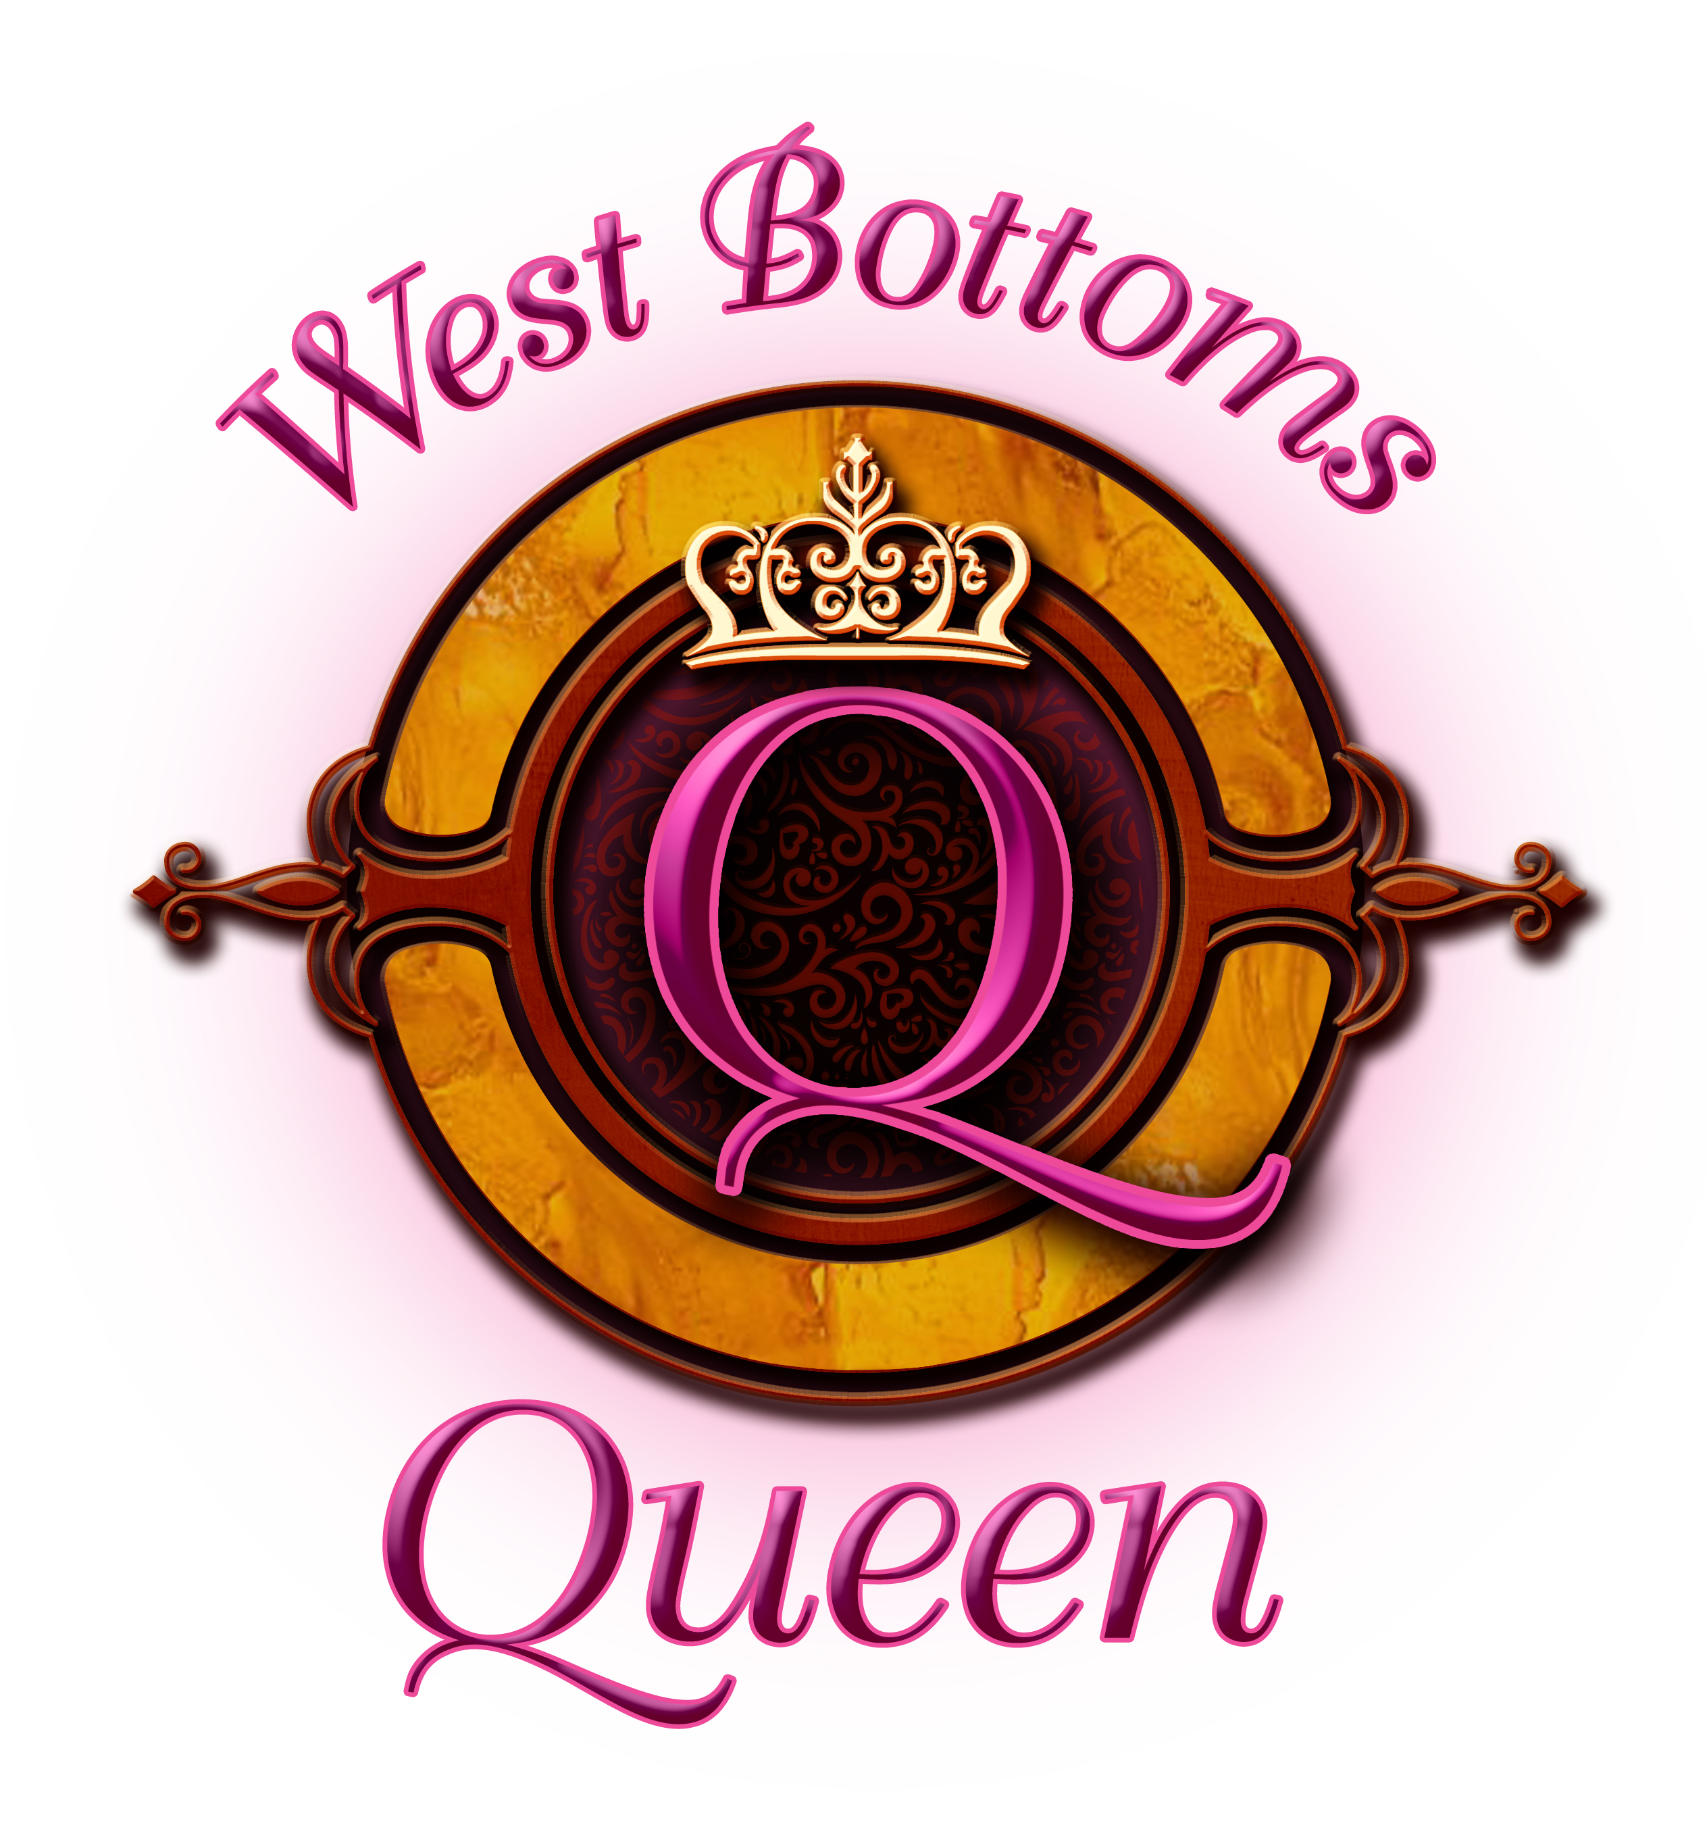
CONTACT: Amber Arnett-Bequeaith VP West Bottoms Entertainment District Assoc. 816.842.4280
LOCATION: 1401 W. 13th St., KCMO 64102

FOR IMMEDIATE RELEASE

Entertainment Returns to the West Bottoms with Booms and Beats in the Bottoms
First Friday Weekend July 3-5, 2020

KANSAS CITY, MISSOURI, June 24, 2020 – West Bottoms First Friday event organizers have announced their July Booms and Beats First Friday Weekend, this July 3-5. Weekend shoppers will enjoy free live performances featuring band BQ Ocean Blu. The band is newly signed with Union Entertainment in Nashville. Food trucks, area bistros, and coffee shops all compliment the experience of shopping in these vintage and apparel stores throughout the 13-block district.

Visitors may bring their leashed dogs and enjoy the band playing under the historic 12th Street Bridge. The band will accept donations to share with the Greater Plains ASPCA to assist with nurturing the animals in their care.

Visitors can also peek inside the historic Rumely event space while they are having an open house on Friday and Saturday to show the remodeled space and offer a chance to win prizes.

“Families and friends are looking for something to do this weekend to celebrate Independence Day, we’ll we offer a weekend of free entertainment,” said Amber Arnett-Bequeaith, area spokesperson and ‘queen of the West Bottoms.’ “The West Bottoms First Friday Weekend is often called Festival of the Full Moon – a nod to Full Moon Productions that helps the district shine. The month’s full moon falls on the last night of the First Friday Weekend. The July moon is the Thunder Moon due to common seasonal storms. Our events are during the day and we expect it will be beautiful.”

The West Bottoms is known for its charming, clean, vast spaces inside buildings and outside for visitors to leisurely stroll and enjoy. Stores request masks to be worn and they will be following city occupancy guidelines to promote social distancing.

About the West Bottoms Historic Entertainment District:
The West Bottoms Historic Entertainment District, located just off the 12th Street Bridge, has 22 warehouses in a thirteen-block area with approximately 600 vendors and more than 25 stores and restaurants. Many of the large, multi-story buildings have histories starting over 120 years ago. They have now repurposed this vast space to earn the title of the largest, year-round, indoor vintage and entertainment district. Since 1988, the District is the destination for interior decorators and designers, collectors and consumers seeking stylish décor and gift options with history and patina that cannot be duplicated. The weekend’s street entertainment, food trucks, and bars are all part of the Festival of the Full Moon. Full Moon Escape Rooms add another adventure option in the area. www.westbottoms.com

JULY’S FESTIVAL OF THE FULL MOON FIRST WEEKEND PLANNER
Friday through Sunday, July 3-5, 2020

- West Bottom’s Shopping – Festival of the Full Moon Weekend
Open Friday through Sunday - Shops Open at 8:30 A.M.
Highlighting stores with specials:
Serendipity – Christmas in July and special painting demos with Dixie Belle Paint
Dusted Attic – Door prizes and free drink samples
Sincerely Ellis – Spend $100+ get a free KC t-shirt while supplies last

- BQ Ocean Blu Band Performances – The band is newly signed with Union Entertainment – Nashville. They play an eclectic mix of s favorites from the past decades and music genres, in addition to their original music
  - Band will play Friday and Saturday from 11am-3pm under the 12th Street Bridge.

- Open House – Rumely Remodeled space
  - See the space and enter to win prizes
  - Friday - 3pm-6pm and Saturday - 10am-3pm

- Food Truck Wine & Dine
Various food trucks and full-service bars line the streets.
Available Friday, Saturday and Sunday, off the 12th St. Bridge

- Full Moon Escape Rooms: Beast’s Tool Room & Ghost of Merlin Room
Opens 10am-9pm Tuesday-Saturday. fullmoonescape.com reserve online or walk-ins welcome.

